PRESS RELEASE

Roasted Films
Roasted Studios
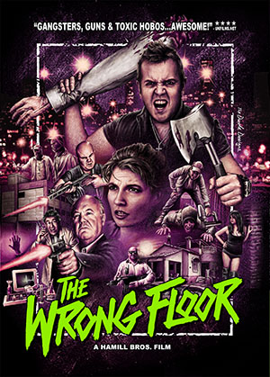
Llimah International Ltd
Unit 1 Baker Street
Leicestershire LE67 4GA
+44 (0)1530 815004

Contact Information
Marc Hamill
Director
+44 (0)1530 815004 (office)

Carl Hamill
Producer
+44 (0)1530 815004 (office)

info@roastedfilms.co.uk

FOR IMMEDIATE RELEASE

British made ‘Grindhouse’ movie hits Hollywood.

Leicester UK – 15th October 2015 – Roasted Films, an independent filmmaking group from Leicester strike a deal with international distribution company Cinema Epoch to be represented at Hollywood’s American Film Market.

Britain has long been established as an exporter of exciting and innovative films, but Grindhouse has always been viewed as an American / Italian niche. That golden pocket between b-movie and trash has traditionally been overlooked or unattainable by British filmmakers. Until now. For the first time in recent history, a British Grindhouse movie will be marketed along side its American counterparts for international distribution.

Roasted Films, founded in 2012 by The Hamill Bros, is a small group of local filmmakers based in Leicestershire. With Grindhouse themes and techniques at its core, the group soon created a buzz nationally. The Wrong Floor attracted cast & crew members from across the UK. It soon became clear that Grindhouse was no longer just a sub genre indulgence for American filmmakers, but something that was being re-born right here in the UK. With a regular cast and crew of over one hundred like-minded individuals, Roasted Films believe that The Wrong Floor is just the beginning of this new-wave genre.

The Wrong Floor will be hitting The American Film Market in November 2015. The film is currently in the final stages of post-production. There is an indiegogo fundraising campaign currently running to help finance the completion. Contribution perks include pre-release DVDs, Blu-rays, limited edition posters, props, premiere tickets, production credits and many more.

To support The Wrong Floor visit:
http://igg.me/at/thewrongfloor/x/8859939
****
Roasted Films Website: http://www.roastedfilms.co.uk
The Wrong Floor Facebook: http://www.facebook.com/thewrongfloor
Roasted Films Facebook: http://www.facebook.com/thewrongfloor
Cinema Epoch Website: http://www.cinemaepoch.com
The Wrong Floor UK Trailer: https://youtu.be/3F5SyE14h74

